

**Shreyas Foundation**

**Shishu Vibhag**

**Academic Year 2023-24**

**Activity card for the children of age group 3+ 4+ 5+**

Buckle Frame

**Practical Life:** Dressing

**Level:** Primary

**Age:** 4

**Prerequisites:** Button Frame

**Materials:** Buckle Frame

In this activity the child learns how to buckle and unbuckle.

**Contents**

1 Presentation

2 Points of Interest

3 Control of Error

4 Variations and Extensions

5 Material

5.1 Make Your Own

5.2 Where to Buy

6 Further Reading

**Presentation**

1. step one

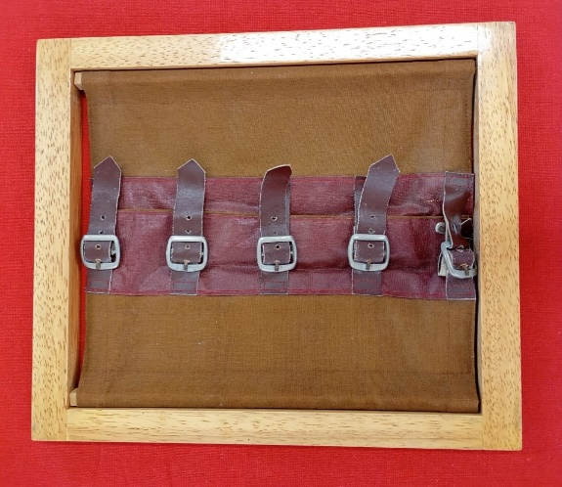

1. Next step

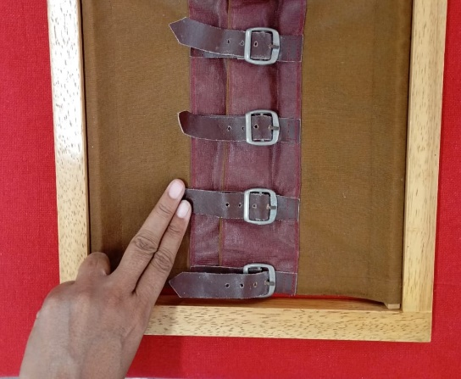

1. Next step

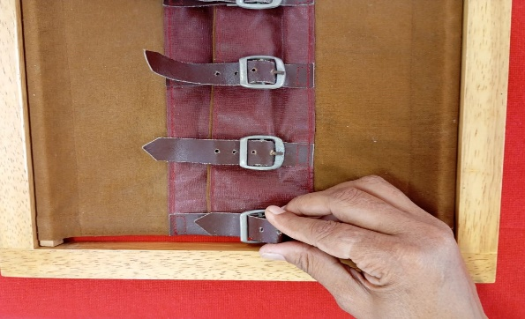

1. Next step

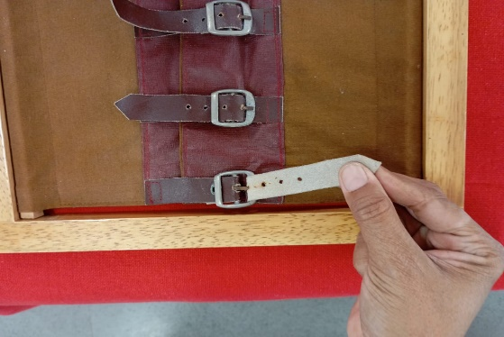

1. Next step

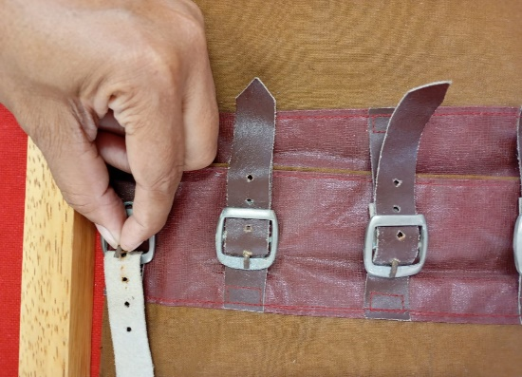

1. Next step

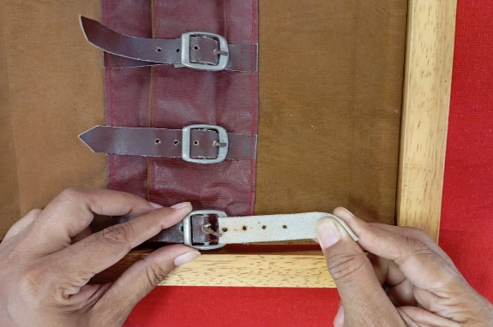

1. Next step

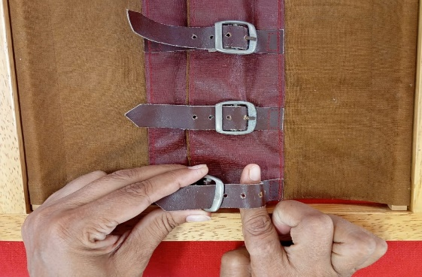

1. Next step

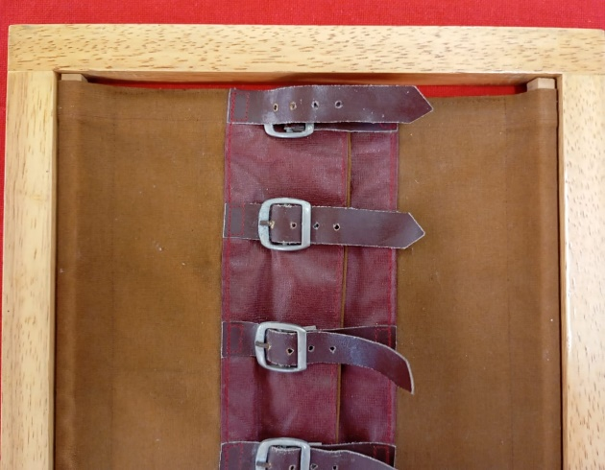

1. Next step

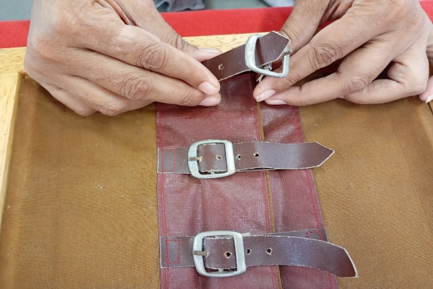

1. Next step

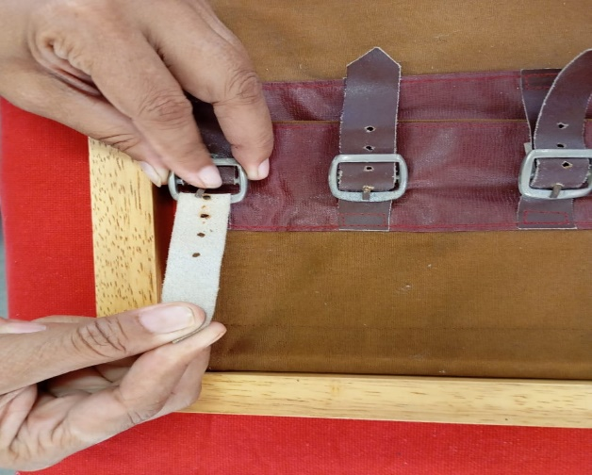

1. Next step

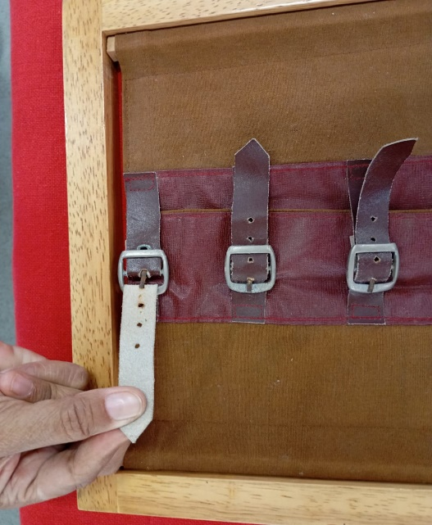

1. Next step

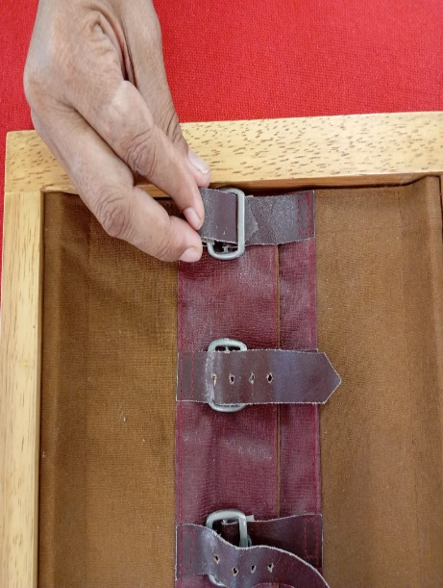

1. Next step

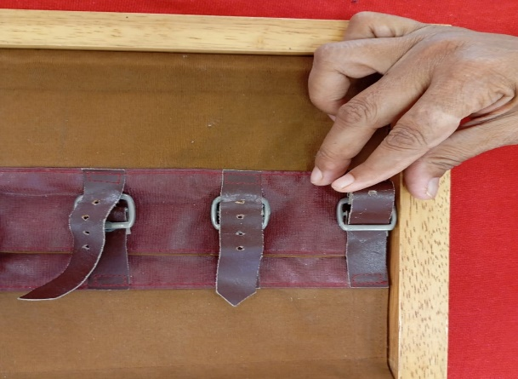

1. Next step

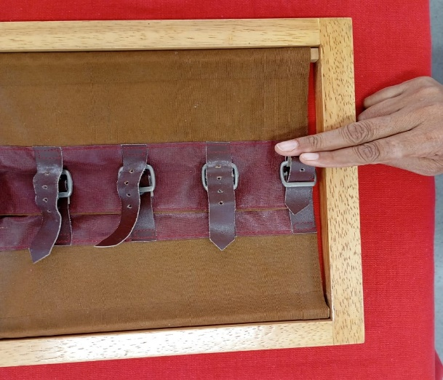

## **Points of Interest**

## **Control of Error**

## **Variations and Extensions**

## **Material**

### Make Your Own